

[Global Strategy](https://hbr.org/topic/subject/global-strategy)

How Netflix Expanded to 190 Countries in 7 Years

by [Louis Brennan](https://hbr.org/search?term=louis%20brennan)

October 12, 2018, Updated October 12, 2018

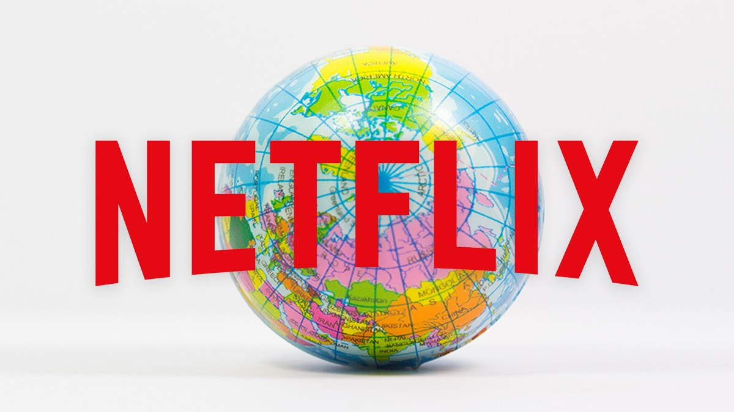

Fernando Trabanco Fotografía/Getty Images

Summary. Netflix’s global growth is a big factor in the company’s success. It

operates in over 190 countries, and its international streaming revenues now exceed its domestic revenues. But only eight years ago Netflix was only in the U.S. How did it expand so quickly? First, it didn’t enter all markets at once. It started slowly, in countries that were similar to its U.S. home market. Using what it learned in these markets, it expanded to a few dozen countries by 2015, and then continued learning and growing from there. Second, it adapted to local cultures and preferences, using that knowledge to appeal to customers all over the world, both with its content offerings and with the partnerships it formed with local

stakeholders. Netflix’s strategy constitutes a new approach to growth that the author calls exponential globalization, and it’s one that other companies can use

too. close

[Leer en español](https://hbr.org/2018/10/how-netflix-expanded-to-190-countries-in-7-years?language=es)

Netflix’s global growth is a big factor in the company’s success. By [2017 it was operating in over 190 countries, and today close to 73 million of its some 130 million subscribers are outside the U.S. I](https://s22.q4cdn.com/959853165/files/doc_financials/quarterly_reports/2018/q2/FINAL-Q2-18-Shareholder-Letter.pdf)n the second quarter of 2018, its international streaming revenues exceeded domestic streaming revenues for the first time. This is a remarkable achievement for a company that was only in the U.S. before 2010, and in only 50 countries by 2015.

Other U.S. internet companies have scaled internationally, of course (Facebook and Google are two obvious examples). But Netflix’s globalization strategy, and many of the challenges it’s had to overcome, are unique. Netflix must secure content deals region by region, and sometimes country by country. It also must face a diverse set of national regulatory restrictions, such as those that limit what content can be made available in local markets.

International subscribers, many of whom are not fluent in English, often prefer local-language programming. And many potential subscribers, accustomed to free content, remain hesitant to pay for streaming services at all.

Furthermore, strong competition in streaming already exists in many countries. In France and India, for example, homegrown leaders offer local-language video content, thus depriving Netflix of first-mover advantage. In some countries, like Germany and India, rivals such as Amazon Prime were already established. Yet the majority of Prime subscribers are in the U.S., and Netflix has managed to make inroads into even those markets where Prime [arrived first. Now Netflix, with its global reach, has more subscribers worldwide than all other pure streaming services combined.](http://time.com/money/5341022/netflix-subscribers-2018-stock-amazon-prime/)

Netflix’s success can be attributed to two strategic moves — a three-stage expansion process into new markets and the ways it worked with those markets — which other companies looking to expand globally can use too.

**Netflix did not try to enter all markets at once.** Rather, it carefully selected its initial adjacent markets in terms of geography and psychic distance, or perceived differences between markets. For example, its earliest international expansion, in 2010, was to Canada, which is geographically close to and shares many similarities with the United States. Netflix was thus able to develop its internationalization capabilities in locations where the challenges of “foreignness” were less acute. In doing so, the company learned how to expand and enhance its core capabilities beyond its home market.

In that sense, the first phase of its globalization process was consistent with the traditional model of expansion. But from the experience and learning it gained in that process, Netflix developed the capabilities to expand into a diverse set of markets within a few years — the second phase of the process.

This second phase, involving a faster and more-extensive international expansion, saw Netflix extend its footprint to some 50 countries, drawing on the lessons it learned in the first phase in order to operate in a wider variety of markets. The choice of those markets was influenced by their degree of attractiveness, such as from shared similarities, the presence of affluent consumers, and the availability of broadband internet. The second phase helped Netflix continue learning about internationalization and partnering with local stakeholders while also growing its revenue. Since this phase involved expanding into more-distant markets, it was supported by investments in content geared toward the preferences of those geographies, as well as technological investments in big data and analytics.

The third phase, during which a much-accelerated pace of entry brought Netflix to 190 countries, used everything it had learned from the first two phases. It had gained expertise in the content people prefer, the marketing they respond to, and how the company needed to organize itself. Now Netflix focused on adding more languages (including for subtitles), optimizing its personalization algorithms for a global library of content, and expanding its support for a range of device, operation, and payment partnerships. Six months after entering Poland and Turkey in 2016, for example, Netflix added the local languages to its user interface, subtitles, and dubbing. As with the markets it had entered earlier, the company launched a service targeted at early adopters, and then iterated quickly to add features to attract a wider audience.

Recognizing that in some parts of the world, particularly emerging and developing economies, mobile is the primary way most people access the internet, Netflix also began placing a greater emphasis on improving its mobile experience, including sign-ups, credentials and authentication, the user interface, and streaming efficiency for cellular networks. It has been developing relationships with device makers, mobile and TV operators, and internet service providers as well.

**Netflix has worked with, and responded to, the new markets it’s entered.** The company has partnered with key local companies to forge win-win relationships. In some cases, it has joined with cell phone and cable operators to make its content available as part of their existing video-on-demand offerings. For example, when Vodafone launched a TV service for its customers in Ireland, it included a dedicated Netflix button on its remote [controls. More recently, Netflix announced deals with Telefonica in Spain and Latin America and with](https://www.telefonica.com/en/web/press-office/-/telefonica-to-integrate-netflix-into-its-tv-and-video-platforms-in-latin-america) [KDDI in Japan](http://news.kddi.com/kddi/corporate/english/newsrelease/2018/05/29/3196.html)[.](https://www.telefonica.com/en/web/press-office/-/telefonica-to-integrate-netflix-into-its-tv-and-video-platforms-in-latin-america)

And while Netflix believes that “great storytelling transcends borders,” in the words of Ted Sarandos, Netflix’s chief content officer, the company has responded to customer preferences for

local content: Currently it’s producing original content in 17 different markets. Importantly, Netflix sees such content production as not just local-for-local, but also local-for-global. In other words, it aims to have content attract an audience not only locally, where it is produced, but also more widely. As such, Netflix potentially reaps the benefits of investing in local content all around the world.

To address the protracted process of signing content deals with major studios on a regional or local basis, it has increasingly pursued global licensing deals so that it can provide content across all of its markets at once. Netflix has also begun to source regionally produced content, providing a win-win for these producers, whose local content can find a global audience.

The company is also applying its deep customer insight to international markets, using that knowledge to create content that appeals to a wide range of customer segments. Despite its very rapid internationalization, Netflix implemented in all markets the same customer-centric model of operations that had been key to its success in the United States. It experiments with customer usage data to determine which offerings work best.

Because it operates in so many countries, Netflix is able to try different approaches in different markets. As the number of its international subscribers grows, the performance of its predictive algorithms continues to improve.

Netflix has demonstrated that developing country-specific knowledge is critical for success in local markets. This knowledge needs to be both broad and deep, extending across political, institutional, regulatory, technical, cultural, customer, and competitor domains. Understanding local cultures ensured that Netflix could be sensitive to and respond to their differences. This enhanced its credibility and helped it forge smooth relationships with key stakeholders.

Taken together, the elements of Netflix’s expansion strategy constitute a new approach that I call *exponential globalization*. It’s a carefully orchestrated cycle of expansion, executed at increasing speed, to an increasing number of countries and customers. The approach has helped the company expand far more quickly than competitors. Going forward, Netflix will face increasing competition not only from other global players such as Amazon Prime but also from new entrants and regional or local players. In that regard, it will have to continue to expand its blending of global and regional content.

For a variety of market and technological factors, including the absence of high-speed broadband and a very low level of internet penetration in many parts of the world, exponential globalization was infeasible until a few years ago. With the growth of the internet in general, including on phones, tablets, and smart TVs, Netflix has demonstrated that this strategy is now a viable option. But it requires a mastery of local contexts, including the ability to acquire local knowledge and to demonstrate sensitivity and responsiveness. With the increasing prevalence of winner-take-all markets, companies operating in such markets will need to pursue an internationalization strategy similar to Netflix’s. And when it comes to Netflix’s next stage of growth, and how it will respond to new challengers, the sequel appears likely to be as captivating as the original.

LB

[Louis Brennan](https://hbr.org/search?term=louis%20brennan&search_type=search-all) is a professor at the Trinity Business School at Trinity College Dublin. His areas of teaching and research interest include international business and operations strategy.

Recommended For You

[How Netflix Reinvented HR](https://hbr.org/2014/01/how-netflix-reinvented-hr?ab=at_art_art_1x4_s01)

[To See the Future of Competition, Look at Netflix](https://hbr.org/2018/07/to-see-the-future-of-competition-look-at-netflix?ab=at_art_art_1x4_s02)

[The Best Way for Netflix to Keep Growing](https://hbr.org/2018/08/the-best-way-for-netflix-to-keep-growing?ab=at_art_art_1x4_s03)

[PODCAST](https://hbr.org/podcast/2020/12/ubers-strategy-for-global-success?ab=at_art_pod_1x4_s04)

[Uber's Strategy for Global Success](https://hbr.org/podcast/2020/12/ubers-strategy-for-global-success?ab=at_art_pod_1x4_s04)