**Mozilla VPN won’t connect or keeps disconnecting - How to fix**

If you find that Mozilla VPN is disconnecting or turning off after being activated, you can try the below steps to resolve this issue. These steps are also helpful if Mozilla VPN is connected, but websites fail to load.

**Table of Contents**

* [Disable Firewalls (Desktop)](https://support.mozilla.org/en-US/kb/mozilla-vpn-wont-connect-or-keeps-disconnecting-how-to-fix#w_disable-firewalls-desktop)
  + [For Windows Defender Firewall](https://support.mozilla.org/en-US/kb/mozilla-vpn-wont-connect-or-keeps-disconnecting-how-to-fix#w_for-windows-defender-firewall)
  + [For macOS Application Firewall](https://support.mozilla.org/en-US/kb/mozilla-vpn-wont-connect-or-keeps-disconnecting-how-to-fix#w_for-macos-application-firewall)
* [Reset Mozilla VPN (All platforms)](https://support.mozilla.org/en-US/kb/mozilla-vpn-wont-connect-or-keeps-disconnecting-how-to-fix" \l "w_reset-mozilla-vpn-all-platforms)
* [Related articles](https://support.mozilla.org/en-US/kb/mozilla-vpn-wont-connect-or-keeps-disconnecting-how-to-fix" \l "w_related-articles)

**Disable Firewalls (Desktop)**

If you have a Firewall or Antivirus that also monitors your internet connection, it’s a good idea to disable them or allow an exception for Mozilla VPN. In order to do this, you will need to refer to your specific application's support documentation.

**For Windows Defender Firewall**

1. In the *Windows Start Menu* search bar, type **Allow an app through Windows Firewall** and click on the first result.
2. Click the **Change Settings** button at the top right of the window to make changes.
3. The *Allow another app* button should highlight. Click the **Allow another app** button close to the bottom of the window.
4. Click **Browse**.
5. Navigate to the VPN by going through the following path: **This PC > Windows (C:) > Program Files > Mozilla > Mozilla VPN > MozillaVPN.exe**
6. Click **Add**.
7. Back on the *Allowed apps* window, make sure *mozillavpn* has both the **Private** and **Public** boxes next to it checked.
8. Click **OK** at the bottom.
9. Restart the system.

**For macOS Application Firewall**

1. Open **System Preference**.
2. Click the **Security** or **Security & Privacy** icon.
3. Select the **Firewall** tab.
4. Click the lock icon in the preference pane, then enter an administrator name and password.
5. Click the **Firewall Options** button.
6. Click the **Add Application (+)** button.
7. Select **Mozilla VPN**.
8. Click **Add**.
9. Click **OK**.

**Reset Mozilla VPN (All platforms)**

If none of the above solutions work and Mozilla VPN keeps disconnecting, you can try resetting Mozilla VPN:

1. Open the Mozilla VPN application.
2. Click the *Settings* vpn settings icon icon.
3. Select the **Get Help** option.
4. At the top of the screen that opens, click the **Get help** title 6 consecutive times until *Developer Options* appear at the bottom.

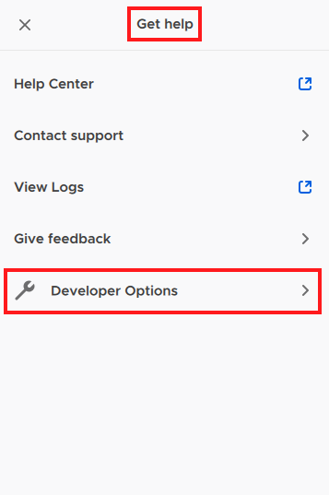

1. Select **Developer Options**.